Q1. GIVE COMMANDS FOR THE FOLLOWING

1. To Run a shell script “merge.sh” at the background.

ANS: sh merge.sh&

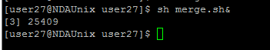

1. To find out lines which contains ‘^M’ characters at the end of every line of the file called sample.txt.

ANS: INPUT

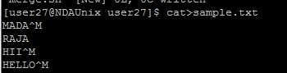

OUTPUT

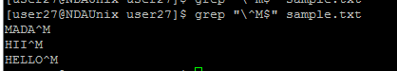

1. To sort a pipe de-limited file as per its third column.

ANS: sort –t “|” -k3,3 emp2

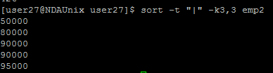

Q2.WRITE SHELL SCRIPT FOR THE FOLLOWING:

4.Write a program to accept file name from the user and check whether the file exists, is readable and has non-zero size. If the file is available show the following details

File created by

Date and time of creation

Size of file. Do all the validation and produce output of each validation.

